|  |  |  |
| --- | --- | --- |
| 6.3.2.a Assessment Brief/Cover Sheet | | |
| Class Group: | | Web Development |
| Assessor: | | 6N1277 |
| Component Title and Code: | | 062CS |
| Assessment Technique: | | Assessment |
| Weighting: | | 35% |
| Title: | | Skills Demonstration #1 |
| Issue Date: | | Monday 8th November 2021 |
| Submission Date: | | Wednesday 8th December 2021 |
| Learning Outcomes Assessed: | | 1, 5, 6, 8, 9 10, 11, 12 14, 15, 16. 17 |
| Guidelines: **Overview:** Students are required to design, create and explain how to host and test a website.  The students will be asked to demonstrate leaning outcomes by preparing a website for a particular business. | | |
| Assessment Criteria: Candidates will be assessed on the following:   |  |  | | --- | --- | | 1. Design a website showing use of current standards in Html and CSS, appropriate use of colors and unit sizes **(5 marks)** 2. Create a website using appropriate use of URLs, links, images, folders, and filenames. Correct use of Html and CSS comments **(15 marks)**  * All HTML validates correctly via W3C HTML Validation Service **(1 mark)** * Appropriate use of CSS selectors to target specific elements **(1 mark)** * Appropriate use of relevant CSS to style page elements as specified in brief **(1 mark)** * Appropriate use of colors based on an understanding of color theory **(1 mark)** * Appropriate use of size units for modifying element properties such as margin, padding, border size **(1 mark)** * Demonstrated understanding of typographical concepts. **(1 mark)** * Demonstrated understanding of accessibility concepts and best practices. **(1 mark)** * Demonstrated understanding of current HTML and its uses. **(1 mark)** * Demonstrated understanding of current CSS and its uses. **(1 mark)** * Appropriate use of appropriate URLs for related images, CSS files, and hyperlinks. **(1 mark)** * All links work as expected. **(1 mark)** * All images display properly and as specified in the brief. **(1 mark)** * Appropriate use of folders to organize files on the web server. **(1 mark)** * Appropriate file names (based on best practices as described in brief). **(1 mark)** * Appropriate use of HTML and CSS comments**. (1 mark)**  1. Explain how to host a website showing an understanding of typographical and accessibility concepts. Include screenshots. **(10 marks)** 2. Test a Website **(5 marks)** |  | | | |
| Learner Name: |  | |
| I confirm that:   1. I have been provided with information about Cork ETB’s assessment and appeals procedures and my responsibilities with regard to assessment 2. The assessment work produced by me is all my own original work | | |
| Learner Signature: | | |
| Date: | | |

|  |
| --- |
| **Note to Learners:**   * Assessments will not be accepted without this coversheet. * Plagiarism is the presentation of someone else’s ideas, arguments, concepts or work as your own by failing to reference or acknowledge it properly. All such work must be acknowledged. Any learner, who presents another’s work as their own, will be investigated in line with Cork ETB Assessment Malpractice procedures and may be awarded a zero grade. * Learners should keep copies of all assessment submitted, where applicable. |

**Skills Demonstration #1**

Patricia O’Flaherty runs a cake business in Cork. She makes cakes for weddings and special occasions. All of her cakes are made from the finest ingredients and her prices reflect this ( a recent cake sold for €1500). She already has a website (www.atouchofmagic.ie)but is worried that it is not mobile responsive. She also used to run a cake academy from a premises in Carraigaline but this is no longer in operation and needs to be removed from the new website.

The aim of the new website is to engage customers. Patricia wants to emphasize her expert cake making credentials. She wants to display a selection of her cakes that she has on offer. She would like to take bookings online(conversions)

Patricia has a large target audience of females aged 25-45years. She receives a lot of orders for cakes from the US from couples who plan on getting married in Ireland.

Candidates are required to:

1. Prepare a Design Brief for the website
2. Prepare Wireframes and MockUps
3. Prepare final website
4. Show evidence of testing
5. **Design Brief for the website**

Complete Design Brief and submit with work. Include sample profiles of target audience.

1. **Prepare Wireframes and MockUps.**

A detailed layout of the proposed website including wireframing for all pages. The storyboard should contain evidence of design changes along with evidence of redrafting.

1. **Prepare the final website**

The website requires appropriate use of URLs, links, images, folders, and filenames. Correct use of Html and CSS comments. Please choose one of templates used in class.

Give the website an appropriate domain name and assign hosting from a specific web hosting site. Please provide relevant screenshots of this.

It should be linked to a database using a form

1. **Show evidence of testing**

Candidates are required to test website for browser compatibility and CSS compliance. Evidence of testing needs to be included in work.

Test the completed website with regard to

* + - navigation, clarity of presentation
    - Using alternate text in image tags

**Show evidence of testing(contd)**

* Using appropriate HTML tags and any necessary scripting is added for browser compatibility
* Cross browser compatibility
* Evidence of Search Engine Optimisation
* HTML validation through W3C HTML Validation Service

**Submit**

1. **Documentation for your website**

Include this with your completed website and this should include:

* Design Brief
* Wireframes and Mock-Ups
* Copy of source code and screenshots of web pages
* Copy of URL Address for uploaded website

1. **The testing of your website**

* Show evidence using screenshots of testing. You must clearly indicate the exact output of each part of the website
* Screenshots of your test results. (Use Alt and Print Screen to take a screen shot and paste it directly into Word or alternatively use the snipping tool).

**3. Completed website –** upload to Moodle and send a copy to gobrien@ccoc.ie

**In addition to uploading all assignment material to Moodle, Please email a zipped copy of the website and additions to gobrien@ccoc.ie**

|  |
| --- |
|  |



My new site will be a Brochure site about courses in the area of confectionaries It will focus on the following target audiences: People between 18-75 who consume content both on the internet.

|  |  |  |  |  |  |
| --- | --- | --- | --- | --- | --- |
| Name | Mark | Sophie | Jack | Philomena | James |
| Gender | Male | Female | Male | Female | Male |
| Age | 28 | 20 | 36 | 74 | 61 |
| Location | Waterford | Cork | Galway | Cork | Kinsale |
| Occupation | Programmer | Student | Cleaner | Retired | Chemist |
| Income | € 120K | undefined | € 30K | €19K | €59K |
| Reasons | Request Recipe | Content | Buy cake | Wedding Cake | Content |

My site will have the following functionality: free tutorial videos order recipe online.

I will measure the success of my new site using the following Google analytics for traffic via search engines, traffic via direct search, bounce rate, online enquiries received, time spent on pages, engagement with social media – Twitter or any sharing of information.

**Competitors**

Three competitor sites are:

Stuff 4 cakes: <https://stuff4cakes.ie/>

BakeWorld: <https://bakeworld.ie/>

DecoBake: <https://www.decobake.com/>

The style of my site will be minimalistic and informative so that it captures the audience and then makes them comfortable navigating. I decided to go for colours that are less vibrant but that remind me of cakes and other confectioneries. The main aim of my site is to bring the content to the audience without overloading them.

Other sites that I perceive to be professional, competent and lively are

<https://www.gingerbreadhouse.ie/>

<https://sugarcraft.ie/>

<https://www.homebaking.ie/>

<https://sugarcraft.ie/>

​

**Wireframes and MockUps**

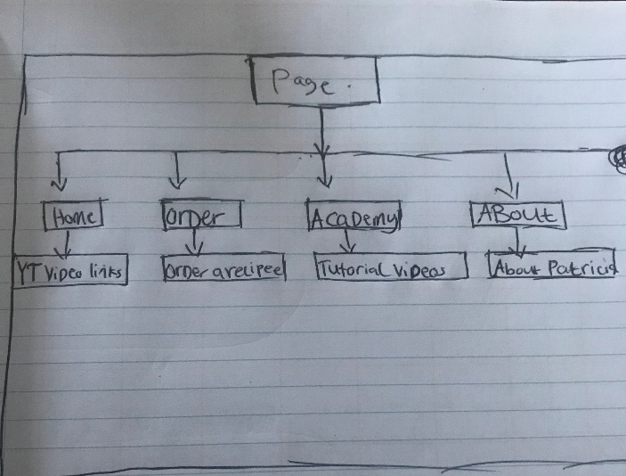

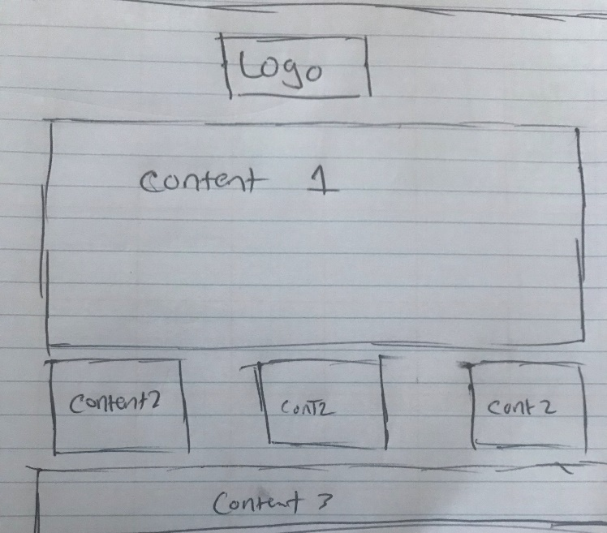

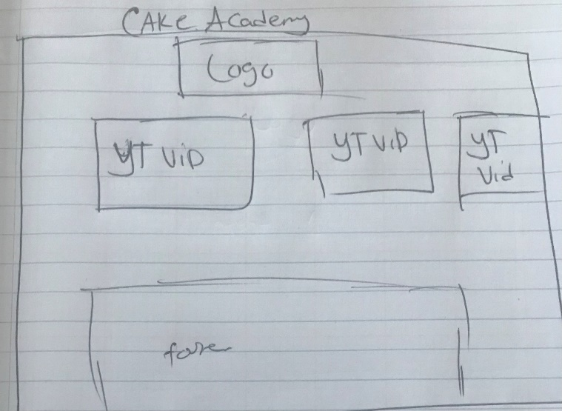

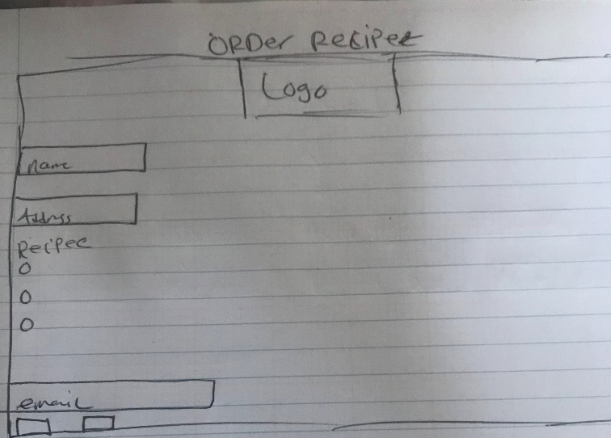

**Final Website**

**Home Page:**

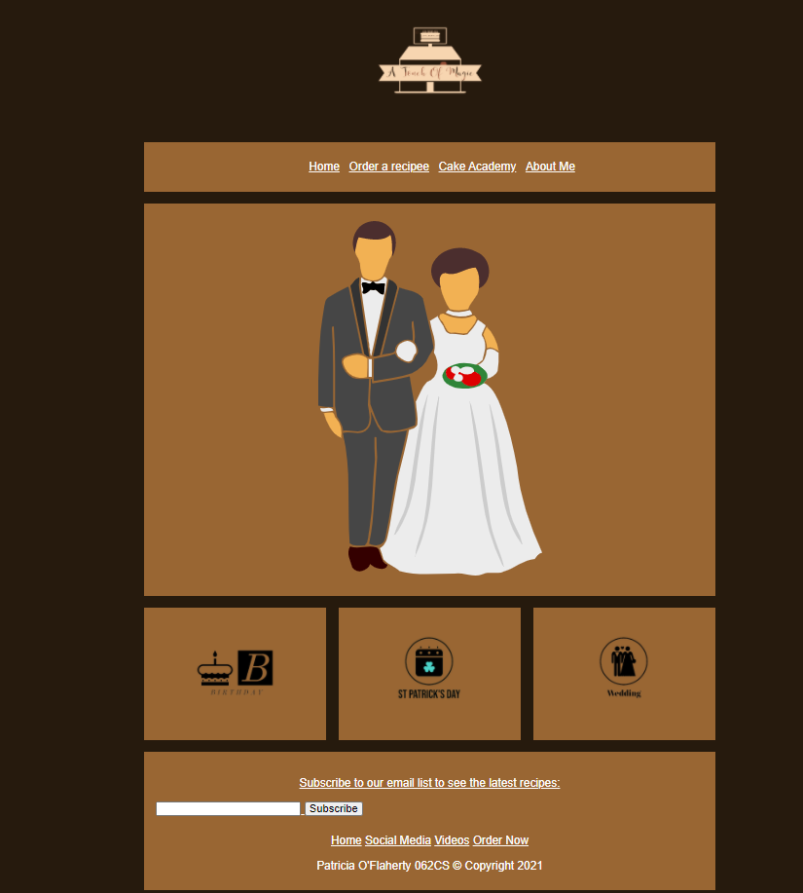

**Order a recipe**

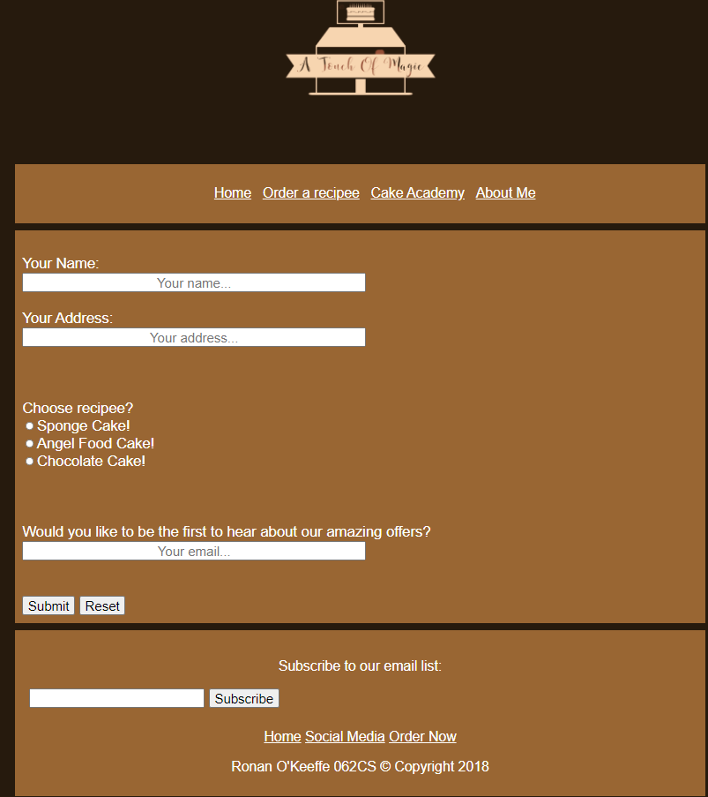

**Cake academy**

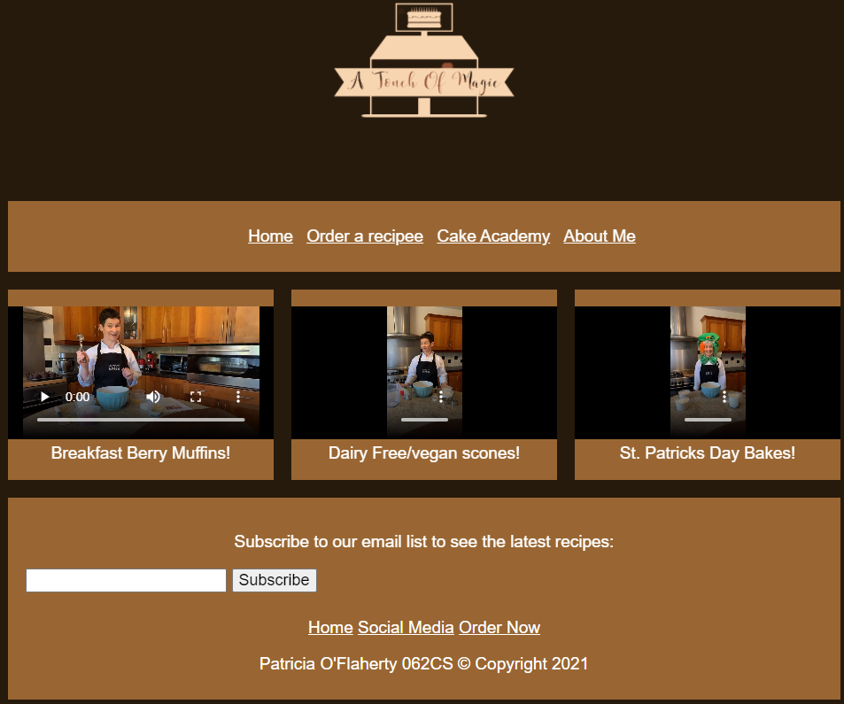

**About**

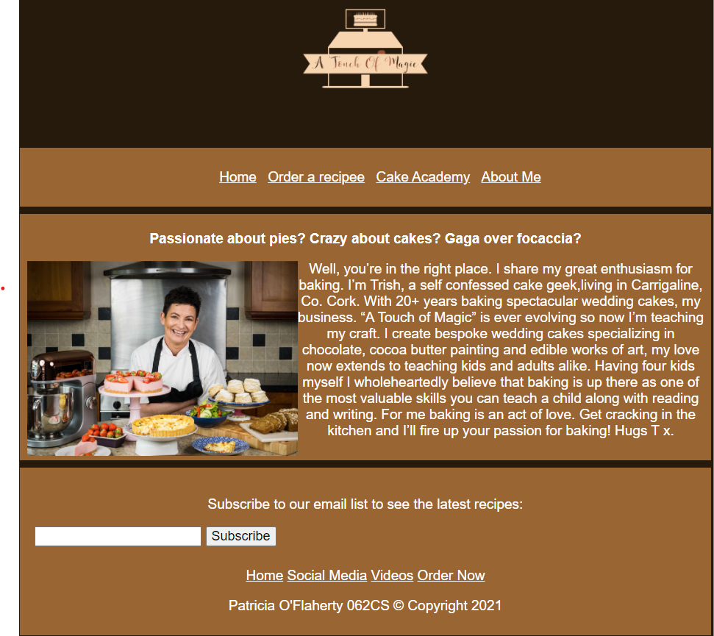

**Testing:**

**Google chrome:**

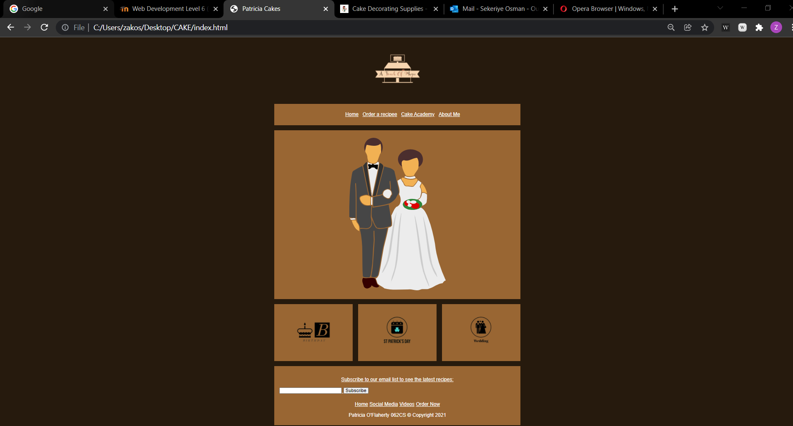

**Microsoft Edge:**

